- Please use handler before the review task on complete action.
- The handler code is checked in on the DV with the file name tm_Mail_Approval.c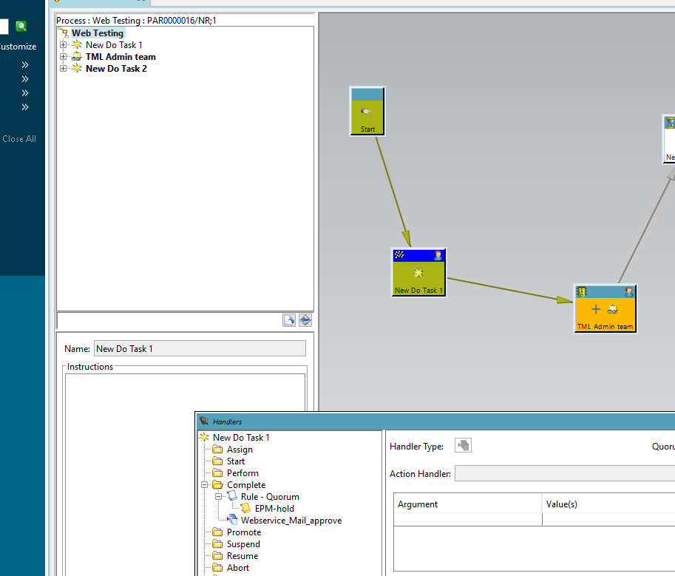
- In the handler, we have called a shell script which is used to trigger an email to the user. The email also sends an attachment, as shown in the snapshot below.
- Please write logic in handler of file creation.
- Please provide file name to shell that will send in attachment.
- Mail Apporval Webservice Path :- This is the name of the preference where the path is specified.
- You can keep your attachment there.
Inputs for shell are like below.
./pFirst_webservice.sh objectname, childParentTaskNam, filename, Web_ParticpantName, taskname, personmail
- ObjectName :- The workflow is initiated.
- businessUnit :- Business unit need be provide like (CV,PV) and for ERC Dev it is CV.
- workFlowName :- Name of the Process or workflow name.
- Userid :- This is the User ID of the user’s workflow in their Worklist.
- filename :- Name of attachment in mail.
- Taskname :- Name of the task that we have to complete using our code.
- Personmail :- User Mail id.
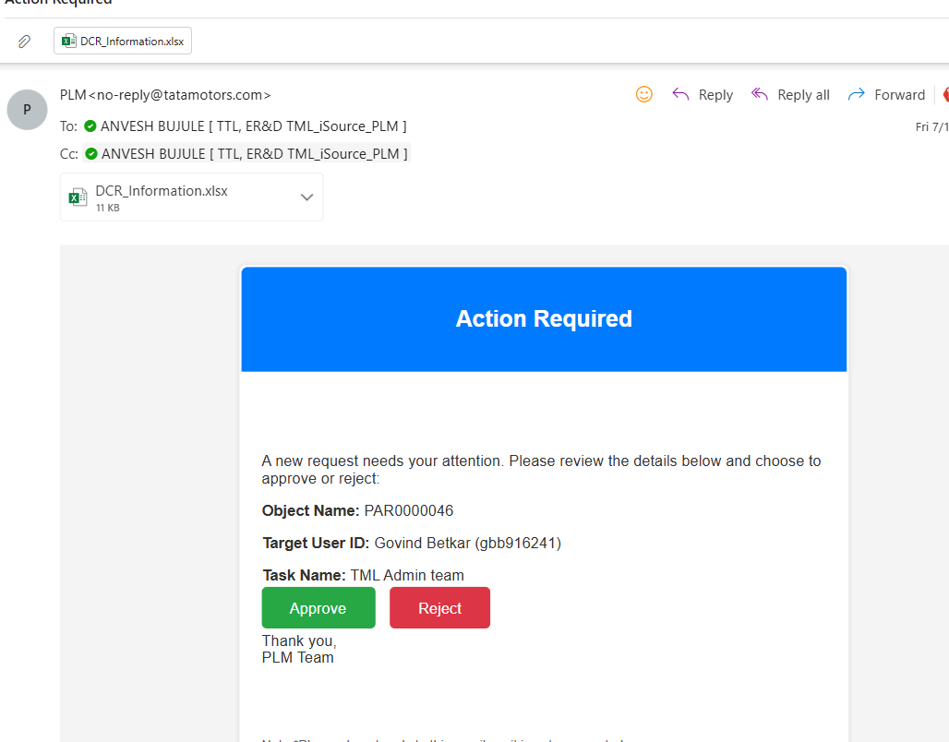

When the user clicks on the Approve or Reject button, another email will open as shown below snap.

Between STARTBELOW and ENDABOVE, the user has to provide a comment. This comment will be stamped on the review task, as shown below. 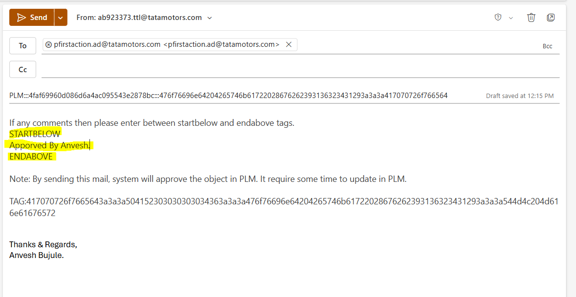

After the mail is triggered, the following web service gets called.
CV: - http://172.22.97.106:9080/cgi/MailWorkFlowDecision.cgi
PV: - http://172.22.97.18:9080/cgi/MailWorkFlowDecision.cgi
The web service code is checked in on the DV with the file name MailWorkFlowDecision.c and MailWorkFlowDecision.h.

